Abstract/Paper title
First Author¹, Second Author², Third Author³
¹ 1st affiliation, address, e-mail address(es)
² 2nd affiliation, address, e-mail address(es)

Abstract – Abstract should be 10 pt bold. The abstract should contain about 100 to 150 words and should contain the main topic faced by the paper. Abstracts are only required for a full paper
- Introduction
These guidelines include complete descriptions of the fonts, spacing, and related information for producing your proceeding manuscripts.
- Language
All manuscript must be in English.
- Paper length
Abstracts should be no longer that 2 pages, full papers should be no longer than 6 pages, including all text, figures, and references.
- Formatting your paper
Papers must use the A4 format. Top margin must be 30 mm, bottom margin must be 25 mm, left and right margins must be 20 mm. All text must be in two-column format. Columns are to be 82 mm wide, with a 6 mm space between them. Text must be fully justified.
All pages must contain a heading starting 15 mm from the top of the page, containing the name and the place of the congress, in Times New Roman 8 pt, left-justified, as shown in the paper templates.
- Page title section
Paper title must be in Times New Roman 24 pt. The authors' name(s) and affiliation(s) appear below the title. Papers with multiple authors and affiliations may require two or more lines for this information.
Authors' names and affiliations must be Times New Roman 12 pt. Affiliations must be italic style.
- Headings
Section heading should be 10 pt in capital letters, centred in the column, and numbered by roman numbers. Section text should be 10 pt.
- Subsection heading
Subsection heading should be in 10pt italic letters and numbered using capital alphabet letters.
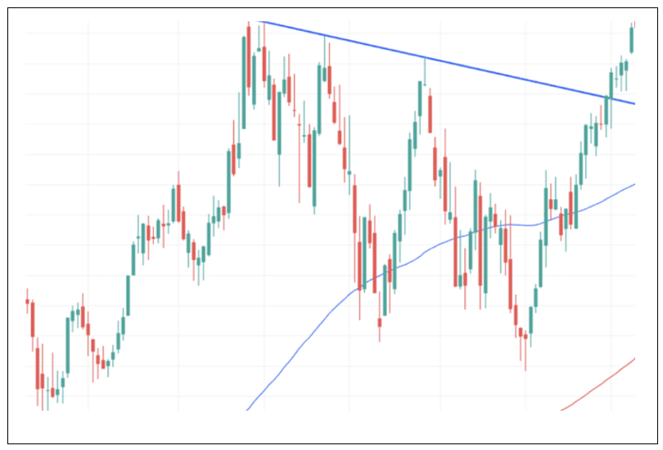Fig. 1. Figure caption.
- Page numbering
Please do not paginate your paper. Page numbers will be inserted when the paper is included in the proceedings.
- Figures and tables
Figures should be centred in the column, with caption on the bottom side. Figure caption should be Times New Roman 10 pt italic. Caption name should be Fig., followed by an arabic number. If possible, position figures at the top of columns, rather than in the middle or at the bottom.
Tables should be centred in the column with the caption on the top. Table caption should be Times New Roman 10pt italic.
Table 1. Table caption.
Column 1 | Column 2 | Column 3
Cell 1 | Cell 2 | Cell 3
Cell 4 | Cell 5 | Cell 6

- Equations
Here is an example of an equation:
(1)
Equations should be centered in the column and numbered on the right side.

- Citations and references
List and number all bibliographical references at the end of the paper. The references must be numbered in order of appearance in the document. When referring to them in the text, type the corresponding reference number in square brackets as shown at the end of this sentence [1]. All citations must be adhered to the format shown in this document template.
References
- E.Balestrieri, L.De Vito, S.Rapuano, D.Slepicka, “Estimating the uncertainty in the frequency domain characterization of digitizing waveform recorders”, IEEE Trans. on Instrum. and Meas., vol.61, No.6, June 2012, pp.1613-1624.
- N.Björsell, P.Daponte, L.De Vito, S.Rapuano, “Automatic signal recognition for a flexible spectrum management,” Proc. of 19th IMEKO World Congress, 2009, vol.1, pp. 444–449.
- S.Mallat, “A wavelet tour of Signal Processing. The Sparse Way”, 3rd edition, Academic Press, New York, USA, 2009.

