IMEKO TC8, TC11 and TC24 Joint Conference

October 11-13, 2023, Madeira, Portugal

PREPARATION OF AN IMEKO TC Conference
Full PAPER IN TWO-COLUMN FORMAT

A. Author¹, B. Author²/Presenter, C. Author³

¹ Business Affiliation, Place, Country, E-Mail Address
² Business Affiliation, Place, Country, E-Mail Address
³ Business Affiliation, Place, Country, E-Mail Address

Abstract:
This paper describes how to prepare a maximum 6-pages full paper for an IMEKO TC Conference. Please observe the following instructions carefully. The abstract is the first paragraph of the summary: it identifies the paper and its major contribution. It should be limited to a few lines (no more than 100 words).
Keywords: 4-5 keywords or terms separated by a semicolon
- Introduction
All papers must be submitted in electronic form through the official IMEKO Conference website in MS-Word format (.docx). Older MS-Word formats (.doc) are also supported but not recommended. The use of other formats or other forms of submission is strongly discouraged.
- Paper, Formats, and Typing
1. The length of the papers is limited, as a rule, to six pages, including illustrations.
2. Manuscripts must be typed in two columns on A4 size (210 mm × 297 mm) paper. Use an 11-point Times New Roman font (or equivalent, no smaller than 9-point and no larger than 12-point).
3. Top/bottom as well as left/right margins must be 20 mm with a 10 mm space between the two columns resulting in a column width of 80 mm. Figures should be prepared in a way that they fit into the column with a good resolution.
4. Manuscripts must be typed single-spaced. Allow any necessary spacing for lines with super and subscripts.
5. Type the title in 14-point capital letters and centre it across the entire width of the page. Type the name(s) of the author(s), business affiliation(s), and mailing address(es) on separate lines and in upper- and lower-case letters. If there are more than five different business affiliations, leave only three on the first page and put the others at the end of the paper.
- Major Headings
Major headings are placed on a separate line, numbered and bold. Auto-numbering should be used by copying headings and inserting them in the place where they are needed. Only major headings are typed in capital letters and are centred in the column. The spacing is - before: 12 points, after: 6 points.
  - Second-level Headings
Second-level headings are placed on a separate line with left alignment, numbered and bold. The spacing of second-level headings is - before: 6 points, after: 0 points.

Sub-Headings
Sub-headings are bold and placed on a separate line with left alignment. The spacing of sub-headings is - before: 6 points, after: 0 points.
Equations: A one-row, two-columns table without frame lines should be used to insert equations. Equations must be numbered using auto-numbering with the number in parentheses. Auto-numbering should be used by copying the whole table, inserting it in the place where it is needed and changing the equation as desired. The integrated equation editor should be used for typing equations:
$c^{2}=a^{2}+b^{2}$ . | (1)
Format variables in italics and use the Roman alphabet for units.
The document can be made more user-friendly by referencing equations with cross-references like: equation (1). To update the automatic numbers, switch to page preview and return to the document.
Units: Strictly adhere to the SI units and the correct use of the units. Use the “Guide for the use of the International System of Units” as published on the NIST web site [4]. Never type units in square brackets “[…]” because they are used to extract the unit from a quantity. Use the dot “.” as decimal sign in all numbers.
Page numbers: Do not type any page numbers.
- Figures and Tables
Drawings and photographs: Prepare drawings and photographs in proper size and place them as close as possible to the text where they are mentioned first in a single paragraph without indentation using inline-with-text positioning. The spacing above is 6 points. Lettering must not be smaller than 8-point. Type single-spaced captions in 10-point letters directly underneath the figures with no indentation, 3 points spacing above and 6 points spacing below. Use auto-numbering by copying a caption and inserting it in the place where it is needed.
The document can be made more user-friendly by referencing Figures with cross-references like: see Figure 1. To update the automatic numbers, switch to page preview and return to the document.
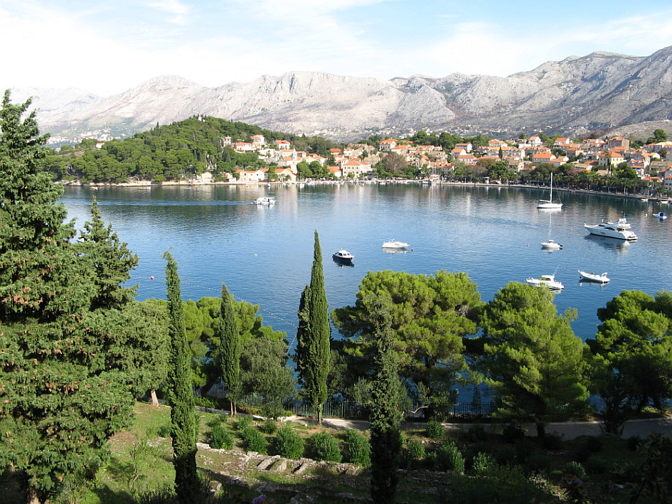
Figure 1: Cavtat near Dubrovnik

If it is necessary to include larger Figures, then place them in sections with one column, see also 5.
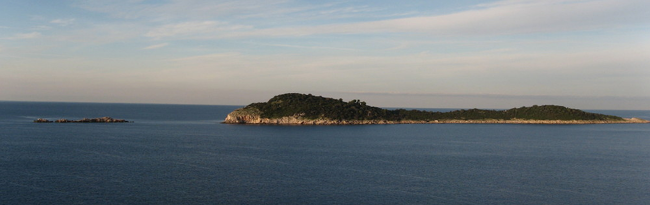
Figure 2: Adriatic sea near Cavtat

Tables: Small tables should fit into one column on one page. Use the same font type as the text. Each table should have a bold heading. Type single-spaced captions in 10-point letters directly above the tables with no indentation, 3 points spacing below and 6 points spacing above. Use auto-numbering by copying a caption and inserting it in the place where it is needed.
The document can be made more user-friendly by referencing Tables with cross-references like: see Table 1. To update the automatic numbers, switch to page preview and return to the document.
Table 1: Important dates and weekdays
 | Date | Weekday
Preparation | 3rd October 2022 | Sunday
Arrival | 10th October 2022 | Monday
Start | 11th October 2022 | Tuesday
End | 13th October 2022 | Thursday
Departure | 15th October 2022 | Friday
Recovery | 16th October 2022 | Saturday

Make sure that there is a blank line after the table.

If it is necessary to include larger Tables, then place them in sections with one column, see also 5.
Table 2: Important dates and weekdays (extended version)
Description of the event or activity | Date | Weekday
Deadline for submission of abstracts | May 1, 2023 | Monday
Notification of authors on acceptance of abstracts | May 30, 2023 | Tuesday
Deadline for submission of full paper | June 20, 2023 | Tuesday
Notification on final acceptance and required corrections | August 1, 2023 | Tuesday
Beginning of the conference | October 11, 2023 | Wednesday
End of the conference | October 13, 2023 | Friday

- Summary
Write a short summary with the most important outcome of the paper.
References: List all references at the end of the summary. Use auto-numbering as shown in section 6 below. A new reference can be added in any place of the list by hitting Enter at the end of one of the references. Unnecessary references can be removed by deleting the whole paragraph. The numbers will be updated. When referring in the text to an entry in the list of references, use a cross-reference as shown in Figure 3. It should look like: see [4].
One hint to cross-references: make sure that only “Label and number” or “Paragraph number” are inserted and not the “Entire caption”.
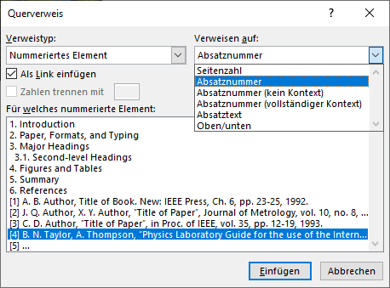
Figure 3: Select cross-references (German MS Word)
If it is necessary to include larger Figures or Tables like Figure 2 and Table 2, then one-column sections must be defined. This is done using Breaks (Page Layout). Two breaks define three sections: one before the first break, one after the first and before the second breaks and a last one after the second break. For each section the number of columns can be defined independently. This template contains seven sections, all sections with an even number contain two columns, sections with an odd number have only one column.
If you want to further improve your paper, please look at the document properties. There you can enter the “Title” of the paper as well as “Tags” (keywords), “Comments” and “Authors”. This information will be kept even when a PDF file is generated from the Word document.
- References
- A. B. Author, Title of Book. New: IEEE Press, Ch. 6, pp. 23-25, 1992.
- J. Q. Author, X. Y. Author, “Title of Paper”, Journal of Metrology, vol. 10, no. 8, pp. 1-20, June 1991.
DOI: 10.21014/acta_imeko.v0i1.13
- C. D. Author, “Title of Paper”, in Proc. of IEEE, vol. 35, pp. 12-19, 1993.
DOI: 10.21014/acta_imeko.v0i1.13
- B. N. Taylor, A. Thompson, “Physics Laboratory Guide for the use of the International System of Units”, NIST Special Publication 811, 2008 Edition. Online [Accessed 20190920]:
https://www.nist.gov/sites/default/files/documents/2016/12/07/sp330.pdf
- …

